**Libary book management**

**author(s):**Demir Yigit

This project is about libary book assignment. A brief summary of small libary system.  
The management from small libaries has specific code for books and members for They will find the books easy and clear.  
  
  
If there is a mistake I would like to correct as soon as possible  
this is my school mail: xdemy002@studenti.czu.cz

**Workspace**

(Books select: [ :p | p location = 'A1' ])

collect: [:r | r racks]

Members select:[:m | m accountNumber= 12668 ]

collect: [:p | p book ]

(Books select: [ :p | p publicationDate > 1900 ])

collect: [:m | m Member]

**Workspace Objects**

* Books :Set
* Libarians :Set
* Members :Set
* Racks :Set

**Script**

Libarians := Set new.

l1 := Libarian new.

l1 name: 'Jana';

surname: 'Melboourne';

adress: 'Prague1, Czech Republic ';

libarianNumber: 022551.

l2 := Libarian new.

l2 name: 'Michael';

surname: 'Lee' ;

adress: 'Prague 6, Czech Republic';

libarianNumber: 022984.

Members := Set new.

m1 := Member new.

m1 name: 'Mike';

surname: 'Tyson';

adress: 'Prague 6, Czech Republic';

accountNumber: 012668.

m2 := Member new.

m2 name: 'Maria';

surname: 'Lopez';

adress: 'Prague 2, Czech Republic ';

accountNumber: 012786.

m3 := Member new.

m3 name: 'Marta';

surname: 'Novakova';

adress: 'Prague 4, Czech Republic ';

accountNumber: 012337.

m4 := Member new.

m4 name: 'Miroslav';

surname: 'Kovac';

adress: 'Prague 3, Czech Republic ';

accountNumber: 012759.

m5 := Member new.

m5 name: 'Monika';

surname: 'Vlckova';

adress: 'Prague 1, Czech Republic ';

accountNumber: 012120.

m6 := Member new.

m6 name: 'Michal';

surname: 'Hruska';

adress: 'Prague 7, Czech Republic ';

accountNumber: 012889.

Books := Set new.

p1 := Book new.

p1 title: 'To Kill a Mockingbird';

author: 'Harper Lee';

iSBN: '978-0446310789';

location: 'A1';

publicationDate: 1960.

p2 := Book new.

p2 title: 'The Catcher in the Rye';

author: 'J.D. Salinger';

iSBN: '978-0316769174';

location: 'B2';

publicationDate: 1951.

p3 := Book new.

p3 title: '1984';

author: 'George Orwell';

iSBN: '978-0451524935';

location: 'A1';

publicationDate: 1949.

p4 := Book new.

p4 title: 'Pride and Prejudice';

author: 'Jane Austen';

iSBN: '978-0486284736';

location: 'B2';

publicationDate: 1813.

p5 := Book new.

p5 title: 'The Great Gatsby';

author: 'F. Scott Fitzgerald';

iSBN: '978-0743273565';

location: 'A1';

publicationDate: 1925.

p6 := Book new.

p6 title: 'Moby-Dick';

author: 'Herman Melville';

iSBN: '978-0142000083';

location: 'B2';

publicationDate: 1851.

Racks := Set new.

r1 := Rack new.

r1 location: 'A1'.

r2 := Rack new.

r2 location: 'B2'.

m1 borrowedBooks add: p1.

m1 borrowedBooks add: p2.

m4 borrowedBooks add: p4.

m6 borrowedBooks add: p6.

r1 books add: p5.

r1 books add: p3.

Libarians add: l1; add: l2.

Members add: m1; add: m2; add: m3; add: m4; add: m5; add: m6.

Books add: p1; add: p2; add: p3; add: p4; add: p5; add: p6.

Racks add: r1; add: r2.

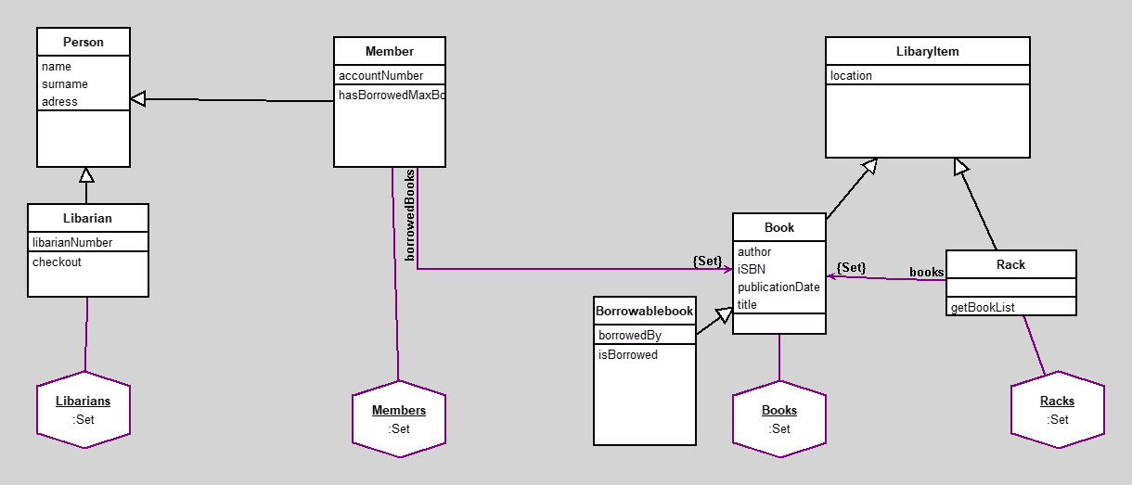

**Classes**

|  |  |  |  |  |
| --- | --- | --- | --- | --- |
| |  | | --- | | **Person** | | *instance variables* adress :String name :String surname :String | | *methods* adress adress: initialize name name: surname surname: | |  |

**code of non-accessing methods:**

* **initialize**
* "generated by Daskalos"
* super initialize.
* name := nil.
* surname := nil.

adress := nil.

|  |  |  |  |  |
| --- | --- | --- | --- | --- |
| |  | | --- | | **LibaryItem** | | *instance variables* location :String | | *methods* initialize location location: | |  |

**code of non-accessing methods:**

* **initialize**
* "generated by Daskalos"
* super initialize.

location := nil.

|  |  |  |  |  |
| --- | --- | --- | --- | --- |
| |  | | --- | | **Member** | | *instance variables* accountNumber :Number borrowedBooks :Set | | *methods* accountNumber accountNumber: borrowedBooks hasBorrowedMaxBooks initialize | |  |

**code of non-accessing methods:**

* **hasBorrowedMaxBooks**

^borrowedBooks size >= 3

* **initialize**
* "generated by Daskalos"
* super initialize.
* accountNumber := nil.

borrowedBooks := Set new.

|  |  |  |  |  |
| --- | --- | --- | --- | --- |
| |  | | --- | | **Libarian** | | *instance variables* libarianNumber :Number | | *methods* checkout initialize libarianNumber libarianNumber: | |  |

**code of non-accessing methods:**

* **checkout**
* | borrowedBook BookedBook |
* borrowedBook := BookedBook new book: Book borrower: Member.
* Book setBorrowed: true.

^borrowedBook

* **initialize**
* "generated by Daskalos"
* super initialize.

libarianNumber := nil.

|  |  |  |  |  |
| --- | --- | --- | --- | --- |
| |  | | --- | | **Book** | | *instance variables* author :String iSBN :String publicationDate :Number title :String | | *methods* author author: initialize iSBN iSBN: publicationDate publicationDate: title title: | |  |

**code of non-accessing methods:**

* **initialize**
* "generated by Daskalos"
* super initialize.
* author := nil.
* iSBN := nil.
* publicationDate := nil.

title := nil.

|  |  |  |  |  |
| --- | --- | --- | --- | --- |
| |  | | --- | | **Rack** | | *instance variables* books :Set | | *methods* books getBookList initialize | |  |

**code of non-accessing methods:**

* **getBookList**

^bookList

* **initialize**
* "generated by Daskalos"
* super initialize.

books := Set new

|  |  |  |  |  |
| --- | --- | --- | --- | --- |
| |  | | --- | | **Borrowablebook** | | *instance variables* borrowedBy :String | | *methods* borrowedBy borrowedBy: initialize isBorrowed | |  |

**code of non-accessing methods:**

* **initialize**
* "generated by Daskalos"
* super initialize.

borrowedBy := nil.

* **isBorrowed**
* "Return true if the book is currently borrowed."

^borrowed

**Links**

Data file and class source.  
  
Generated by Daskalos - Object Modeling Tutor (C) 2006 V. Merunka  
May 1, 2023